DSA Lab 2
Q1
Source code
import timeit

def Prime(nabeel):
for x in range(2,nabeel-1):

if (nabeel % x ) ==0:
print(nabeel, "is not a prime number")
break
else:
print(nabeel, "is a prime number")
break

nabeel = int(input("Enter the number: "))
Prime(nabeel)

end_time = timeit.timeit()
print ("Execution time: ", end_time)

Output
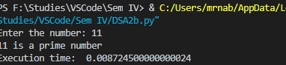
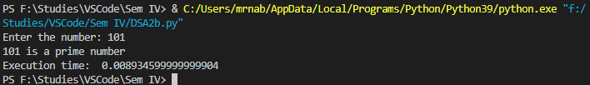
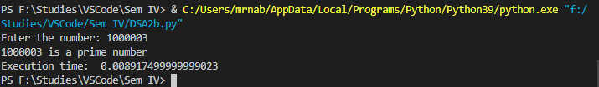
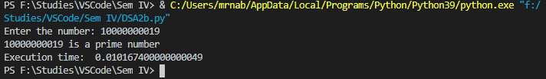
Q2
Source code
import math
import timeit

def Prime(nabeel):
for x in range(2,int(math.sqrt(nabeel))):

if (nabeel % x ) == 0:
print(nabeel, "is not a prime number")
break
else:
print(nabeel, "is a prime number")
break

nabeel = int(input("Enter the number: "))
Prime(nabeel)

end_time = timeit.timeit()
print ("Execution time: ", end_time)
Output
